|  |  |
| --- | --- |
| **Canon EF 70-200mm f/2.8L IS III USM Lens**  Ống kính Canon EF 70-200mm f/2.8L IS III USM  Canon EF 70-200mm 3 Canon EF 70-200mm 1 Canon EF 70-200mm 2 Canon EF 70-200mm | **Featured information:**   * Anti-vibration: Yes * Aperture: F/2.8-32 * Closest focusing distance: 1.2m * Filter size: 77mm   Price: 1600$  **Specifications:**   * **Focal distance:** 70 - 200mm * **Largest Aperture:** f/2.8 * **Smallest Aperture:** f/32 * **Lens Mount:** Canon EF * **Lens Format:** Full-Frame * **View:** 34° - 12° * **Minimum Focus Distance:** 1.2 m * **Magnification:** 0.21x * **Optical Components:** 23 lenses in 19 groups * **Number of Mouth Blades:** 8 * **Focus Type:** Auto focus * **Anti-Vibration:** Yes * **Filter Size:** 77 mm (Front) * **Size:** 88.8 x 199 mm * **Weight:** 1480 g |

**Description:**

Not only has the exterior design been improved, the Canon EF 70-200mm f/2.8L IS III USM has also been upgraded with an advanced optical structure, supporting optimal image quality improvement, helping photographers unleash your creativity and produce unique works.

#### **Canon EF lens focal length 70-200mm, aperture f/2.8**

This EF mount telephoto lens is designed specifically for Canon Full-Frame format DSLR cameras. However, it can also be used with APS-C models and provides a 112-320mm equivalent focal length range.Constant f/2.8 maximum aperture delivers consistent performance throughout the entire zoom range, for outstanding photography in low-light environments. At the same time, it increases control over depth of field, helping to isolate and highlight the subject from the background, very suitable for taking photos that require good background blur such as portraits, sports, etc.

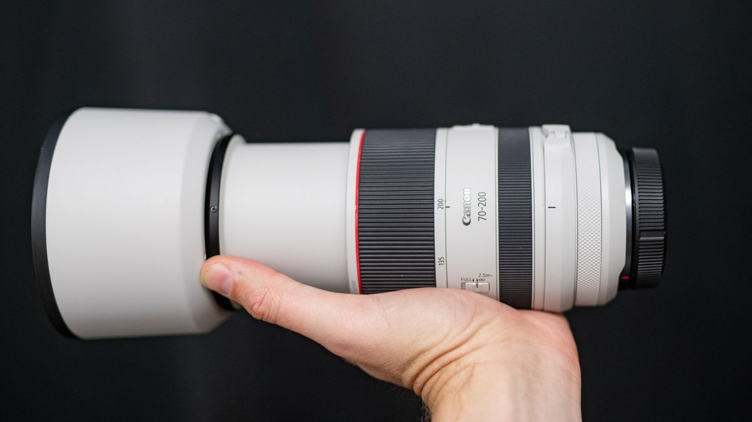

**Uses USM rotating focus motor**

Canon EF 70-200mm f/2.8L IS III USM is equipped with a USM ultrasonic focus motor for fast, accurate and smooth focusing, ensuring highly detailed and sharp images from the camera. central position to edges and corners. Manual focus override mode is also integrated on this lens to help users quickly change AF and MF settings to create unique frames.

